SECTION A-46 MARKS
Attempt all questions in this section.
- (a). Define the term first electron affinity. (01 mark)
………………………………………………………………………………………………………………………………………………………………………………………………………………………………………………………………………………………………………………………………………………
(b). Explain why the first electron affinity is usually exothermic while the second electron affinity is usually endothermic. (02½ marks)
………………………………………………………………………………………………………………………………………………………………………………………………………………………………………………………………………………………………………………………………………………
………………………………………………………………………………………………………………………………………………………………………………………………………………………………………………………………………………………………………………………………………………
(c).State any two factors that affect the magnitude of electron affinity.
(01 mark)
………………………………………………………………………………………………………………………………………………………………………………………………………………………………
- (a)The diagram below shows isotherms of a gas.

Pressure (Nm²)

A
321K
C
B
286K

Volume cm³
- What is the critical temperature of the gas? (0½ mark)
…………………………………………………………………………………………………………………………………………………………………………………………………………………….
- Which isotherm represents the behaviour of an ideal gas? (0½ mark)
…………………………………………………………………………………………………………………………………………………………………………………………………………………..
- What does the region ABC represent? Give a reason. (01 mark)
……………………………………………………………………………………………………………………………………………………………………………………………………………………………………………………………………………………………………………………………………………………………………………………………………………………………..
- Explain the shape of the curve BE. (02 marks)
……………………………………………………………………………………………………………………………………………………………………………………………………………………………………………………………………………………………………………………………………………………………………………………………………………………………..
(b).State one conditions necessary for liquefying a gas. (01 mark)
………………………………………………………………………………………………………………………………………………………………………………………………………………
- (a).An organic compound X reacts with hot aqueous sodium hydroxide solution to give compound W. complete the equation of reaction.
(01 mark)
(b).Name the type of reaction mechanism for the reaction of X with hot aqueous sodium hydroxide solution. (0½ mark)
………………………………………………………………………………………………………
(d).Explain why W still contains one bromine atom. (02½ marks)
………………………………………………………………………………………………………………………………………………………………………………………………………………………………………………………………………………………………………………………………………………………………………………………………………………………………………..
……………………………………………………………………………………………………………………………………………………………………………………………………………………………………………………………………………………………………………………………………………………………………………………………………………………………………….
- Aluminium, silicon and phosphorous belong to period 3 of the periodic table.
(a).For each element, name the structure and write the formula of the oxide. (03½ marks)
Elements | Aluminium | Silicon | Phosphorous
Formula of oxide
Structure of oxide
(b).Write equation for the reaction between oxide of silicon and sodium hydroxide solution. (01 mark)
………………………………………………………………………………………………………………………………………………………………………………………………………………….

- (a).State Graham’s law of gaseous diffusion. (02 marks)
………………………………………………………………………………………………………………………………………………………………………………………………………………………………………………………………………………………………………………………………………………………………………………………………………………………………………………………………
(b).A sample of ammonia was placed at one end A of the 0.8m glass tube held horizontally. At the other end B of the tube was placed a sample of hydrochloric acid and both ends of the tube closed. When the tube was left for some time, a white ring was formed inside the tube.
Calculate the distance between end B and the white ring. (03 marks)
……………………………………………………………………………………………………………………………………………………………………………………………………………………………………………………………………………………………………………………………………………………………………………………………………………………………..
…………………………………………………………………………………………………………………………………………………………………………………………………………………………………………………………………………………………………………………………………………………………………………………………………………………………………………………………………………………………………………………………………………………………………………………………………………………………………………….
- (a).Complete the following equations below. (@01 mark)
(b).Name the type of reaction mechanism in both cases. (01 mark)
…………………………………………………………………………………………………………………………………………………………………………………………………………………..
(c).Draw a well labelled diagram of energy versus reaction path for the reaction in (a). (ii). above. (02 marks)
…………………………………………………………………………………………………………………………………………………………………………………………………………………………………………………………………………………………………………………………………………………………………………………………………………………………………………
………………………………………………………………………………………………………………………………………………………………………………………………………………………………………………………………………………………………………………………………
- The table below shows the first five successive ionization energies of elements V, W, X, Y & Z.
Elements | Ionization energies (KJ/mol)
 | 1st | 2nd | 3rd | 4th
V | 900 | 1800 | 14800 | 2100
W | 500 | 4600 | 6900 | 9500
X | 630 | 1600 | 3000 | 4800
Y | 740 | 1500 | 7700 | 10500
Z | 580 | 1800 | 2700 | 11600

- What is meant by the term ionization energy? (01 mark)
…………………………………………………………………………………………………………………………………………………………………………………………………………………………………………………………………………………………………………………………………………………………………………………………………………………………………………
- (i).State the element which is most likely to form ion with a charge of ⁺1.Give a reason for your answer. (01½ marks)
…………………………………………………………………………………………………………………………………………………………………………………………………………………………………………………………………………………………………………………………………………………………………………………………………………………………………………
(ii).Identify two elements that are in the same group of the periodic table. (01 mark)
………………………………………………………………………………………………………………………………………………………………………………………………………………
(iii).Write the formula of the chloride of V. (01 mark)
………………………………………………………………………………………………………………………………………………………………………………………………………………
- (a).(i).Define the radioactivity. (01 mark)
……………………………………………………………………………………………………………………………………………………………………………………………………………………………………………………………………………………………………………………………………………………………………………………………………………………………………………………………..

(ii).State one property of gamma radiation. (01 mark)
………………………………………………………………………………………………………………………………………………………………………………………………………………………………
(iii).Give the effect of beta radiation to the nucleus of the decaying particle. (01 mark)
………………………………………………………………………………………………………………………………………………………………………………………………………………………………
(b).Complete the following equations for nuclear reactions. (@01 mark)
- ${}_{92}^{236}U$ ${}_{36}^{92}{Kr}$ + …………………… + ${}_{56}^{141}{Ba}$
- ${}_{94}^{239}{Pu}$ + ${}_{2}^{4}{He}$ …………………… + ${}_{13}^{27}{Al}$
- Explain the following observations.
- Concentrated sulphuric acid is not used in preparation alkyliodide in the presence of hydrogen iodide. (03½ marks)
………………………………………………………………………………………………………………………………………………………………………………………………………………………………………………………………………………………………………………………………………………………………………………………………………………………………………….
- It is easier to nitrate methylbenzene than benzene itself. (05 marks)
………………………………………………………………………………………………………………………………………………………………………………………………………………………………………………………………………………………………………………………………
……………………………………………………………………………………………………………………………………………………………………………………………………………………………………………………………………………………………………………………………..
SECTION B-54 MARKS
Attempt any six questions in this section.
- (a).State the conditions under which each of the following elements reacts with water. In each case, write the equations for the reaction.
- Silicon (01½ marks)
………………………………………………………………………………………………………………………………………………………………………………………………………………
- Chlorine (01½ marks)
………………………………………………………………………………………………………………………………………………………………………………………………………………
- Sodium (01½ marks)
………………………………………………………………………………………………………………………………………………………………………………………………………………
- Magnesium (03 marks)
………………………………………………………………………………………………………………………………………………………………………………………………………………
………………………………………………………………………………………………………………………………………………………………………………………………………………
(b).Write an equation for the reaction between aluminium and sodium hydroxide solution. (01½ marks)
……………………………………………………………………………………………………………………………………………………………………………………………………………………

- (a).(i).What is the relationship of Boyle’s law to kinetic molecular theory of gases? (02 marks)
………………………………………………………………………………………………………………………………………………………………………………………………………………………..
………………………………………………………………………………………………………………………………………………………………………………………………………………………..
(ii).Sulphur trioxide and ammonia gases occupy some volumes at 298K and 6.99 x 10⁴Nm⁻².Show which gases have the largest volume.
- marks)
……………………………………………………………………………………………………………………………………………………………………………………………………………………………………………………………………………………………………………………………………………………………………………………………………………………………………………………
……………………………………………………………………………………………………………………………………………………………………………………………………………………………………………………………………………………………………………………………………………………………………………………………………………………………………………………………………………………………………………………………………………………………………………………………………………………………………………………………………………..

(b).(i).What is Dalton’s law of partial pressure? (01 mark)
…………………………………………………………………………………………………………
………………………………………………………………………………………………………………………………………………………………………………………………………………………………………………………………………………………………………………………………
(ii).If 20g of carbon dioxide and 5g of carbon monoxide gases were put in to a 1.00litre container at 27°C.what is the total pressure in the container? (03 marks)
……………………………………………………………………………………………………………………………………………………………………………………………………………………………………………………………………………………………………………………………………………………………………………………………………………………………………………………
……………………………………………………………………………………………………………………………………………………………………………………………………………………………………………………………………………………………………………………………………………………………………………………………………………………………………………………………………………………………………………………………………………………………………………………………………………………………………………………………………………..
- A gas Q contains 30.43% nitrogen and the rest being oxygen gas.0.23g of Q occupied 154.11cm³ at 150°C and 840mmHg.
Determine the:
- Empirical formula of gas Q. (02 marks)
………………………………………………………………………………………………………………………………………………………………………………………………………………………………………………………………………………………………………………………………………………
………………………………………………………………………………………………………………………………………………………………………………………………………………………………………………………………………………………………………………………………………………
- Molecular formula of gas Q. (02½ marks)
[1 mole of a gas occupies 24dm³ at a temperature of 25°C and pressure of 760mmHg]
………………………………………………………………………………………………………………………………………………………………………………………………………………………………………………………………………………………………………………………………………………
………………………………………………………………………………………………………………………………………………………………………………………………………………………………………………………………………………………………………………………………………………………………………………………………………………………………………………………………………………………………………………………………………………………………………………………………………………………………………………………………………………………………
(b).When a mixture of Q and oxygen was bubbled through water, a compound Y was formed.
- Identify Y. (0½ mark)
……………………………………………………………………………………………………………………………………………………………………………………………………………………
- Write equation for the reaction leading to the formation of Y. (01 mark)
……………………………………………………………………………………………………………………………………………………………………………………………………………………
- Briefly describe a test(s) that can be carried out to identify the anion in Y and write equation of the reaction. (03 marks)
………………………………………………………………………………………………………………………………………………………………………………………………………………………………………………………………………………………………………………………………………………
………………………………………………………………………………………………………………………………………………………………………………………………………………………………
- When thin metal foil is subjected to alpha particles from radiation, few alpha particles passed through undeflected.
(a).Explain this observation. (03 marks)
………………………………………………………………………………………………………………………………………………………………………………………………………………………………………………………………………………………………………………………………………………
………………………………………………………………………………………………………………………………………………………………………………………………………………………………………………………………………………………………………………………………………………………………………………………………………………………………………………………………

(b).Mass spectrometer is used to identify isotopes of certain elements.
- What are isotopes? (02 marks)
………………………………………………………………………………………………………………………………………………………………………………………………………………………………………………………………………………………………………………………………………………………………………………………………………………………………………………………………………………………………………………………………………
- State the function of magnetic field in mass spectrometer. (01 mark)
………………………………………………………………………………………………………………………………………………………………………………………………………………………………………………………………………………………………………………………………………………………………………………………………………………………………
- Give one advantage of mass spectrometer. (01 mark)
………………………………………………………………………………………………………………………………………………………………………………………………………………
(c).An element Z has four naturally occurring isotopes with isotopic masses and relative abundance as shown below.
Isotopic mass | Relative abundance (%)
204 | 01.42
206 | 24.07
207 | 22.12
208 | 52.40

Calculate the average atomic mass of Z. (02 marks)
……………………………………………………………………………………………………………………………………………………………………………………………………………………………………………………………………………………………………………………………………………………………………………………………………………………………………………………………………………………………………………………………………………………………………………………………………………………………………………………………
- Complete the following equations and in each case outline a suitable mechanism for the reaction.
…………………………………………………………………………………………………………………………………………………………………………………………………………………………………………………………………………………………………………………………………………………………………………………………………………………………………………………………………………………………………………………………………………………………………………………………………………………………………………………………………………………………………………………………………………………………………………………………………………………………………………………………………………………..

…………………………………………………………………………………………………………………………………………………………………………………………………………………………………………………………………………………………………………………………………………………………………………………………………………………………………………………………………………………………………………………………………………………………………………………………………………………………………………………………………………………………………………………………………………………………………………………………………………………………………………………………………………………………………………
………………………………………………………………………………………………………………………………………………………………………………………………………………………………………………………………………………………………………………………………………………………………………………………………………………………………………………………………………………………………………………………………………………………………………………………………………………………………………………………………………………………………………………………………………………………………………………………………………………………………………………………………………………………………………………………………………………………………………………………………………………………
- The table shows the atomic radius and first ionization energy of some elements in period 3 of the periodic table.
- (i).State how atomic radius of the elements varies across the period. (01 mark)
……………………………………………………………………………………………………………………………………………………………………………………………………………………
(ii).Explain your answer in a (i). (03 marks)
…………………………………………………………………………………………………………………………………………………………………………………………………………………………………………………………………………………………………………………………………………………………………………………………………………………………………………………………………………………………………………………………………………………………………………………………………………………………………………………………………………………………………………………………………………………………………………………………………………………………………………………………………………………..
- (i).Explain how atomic radius affects the ionization energy. (02 marks)
…………………………………………………………………………………………………………………………………………………………………………………………………………………………………………………………………………………………………………………………………………………………………………………………………………………………………………………………………………………………………………………………………………………………………………………………………………………………………………………………………………………………………………………………………………………………………………………………………………………………………………………………………………………..
(ii).Why the first ionization energy of aluminium is lower than that of magnesium. (03 marks)
…………………………………………………………………………………………………………………………………………………………………………………………………………………………………………………………………………………………………………………………………………………………………………………………………………………………………………………………………………………………………………………………………………………………………………………………………………………………………………………………………………………………………………………………………………………………………………………………………………………………………………………………………………………..

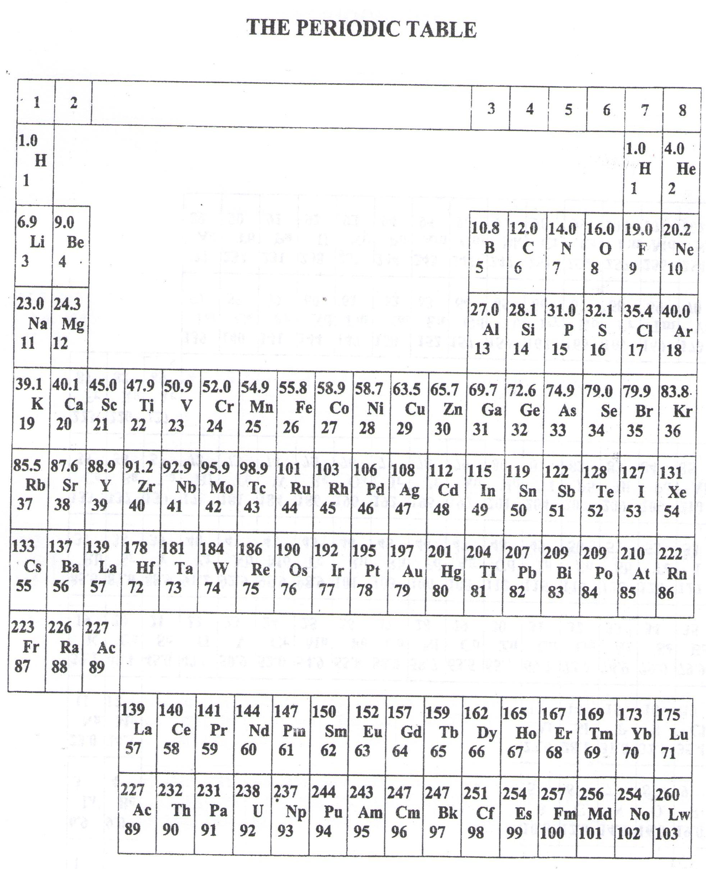
- ===END===
WELCOME TO SENIOR FIVE, YEAR 2019
This is the last page of the printed paper, Page 18

